
BỘ XÂY DỰNG
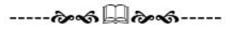
TRƯỜNG ĐH GIAO THÔNG VẬN TẢI TP.HCM


CÔNG NGHỆ PHẦN MỀM
Project: Library management sytem

Group 8:
Trương Hồ Việt Anh
Trần Đức Anh
Đồng Văn Bình
Đặng Nhất Gia Bảo
Nguyễn Minh Vũ

TP. Hồ Chí Minh, ngày 7 tháng 1 năm 2026.
​

Library Management System Specification

Library management system
The requirement is to build a library management system with the following basic features:

Register/Log in to the system:
To borrow books, readers must first register an account (if they don't already have one). To register, readers must provide information such as: Full name, email, and password.
After registering an account, readers proceed to log in. During the login process, readers must provide some information including: username (email) and password. If the login is valid, readers can borrow and return books and manage their personal information. Otherwise, if the login is invalid, the system will report an error and request them to log in again.

Search for/Find books:
research needs, while minimizing the time spent on manual searches as in traditional library models .

Borrow/Return books through the system:
When a reader chooses to borrow a book, the system checks the borrowing conditions such as the number of books remaining, the number of books the reader is currently borrowing, and other library regulations.
Returning books is an essential part of the borrowing process. When a reader returns a book, the system updates the borrowing status (book returned) and increases the number of books in stock .

Review your book borrowing and returning history:
+ Readers can use the book borrowing and returning history feature. Through this history, readers can look up books they have previously borrowed, serving their future learning or research needs. At the same time, this feature also helps the library to statistically track resource usage and assess user needs.
In a library management system, the system administrator (Admin) can be considered a special type of reader (Member). Therefore, the Admin can inherit the basic functions of a reader. It also includes additional administrative functions such as :

Book management:
The library manager can perform operations such as adding, updating, and deleting book information. (Book Title, Book Code, Author, Publisher, Publication Year).
+ When a borrower comes to borrow a book, the manager can search for and look up book information to respond to the borrower.

Audience management:
+ When individuals come to the library and wish to borrow books, they must provide the necessary information to the system administrator . For example, if the borrower is already a library member, they only need to provide basic information such as (Name , membership code) to the administrator for verification in the system.
+ If the individual borrowing a book is not yet a member of the library, they must be asked to register as a member in order to borrow and return books.

Loan and return management:
+ When a borrower wants to borrow any book, the manager needs to check the book's condition before lending it, to facilitate verification of the book's condition after the borrower returns it.
+ When lending books, the manager must create a book lending form. The information on the lending form includes (Borrower's name, Borrower's membership code, Book code, Book title, Book status, Borrowing date, Return date).
+ In cases where borrowers return books late or damage/lose them, the manager must create a list of fines for these cases and update it in the system.

Reports & Statistics
The manager needs to compile and export a list of books currently on loan and a list of books available in the library for convenient management.
+ Create a list of readers who have overdue book payments.
The manager needs to compile a summary of revenue from fines for overdue book borrowings or lost/damaged books and report it monthly or quarterly as required by superiors.

Supplementary Specification
Usability : The interface automatically adjusts to screen size (responsive) . The language used is entirely Vietnamese, with clear and easy-to-read fonts.
Reliability :
The system must operate continuously during library operating hours.
+ In the event of a power outage or sudden power failure, previously saved data must not be corrupted or lost.
When a book is borrowed, the system must update the information immediately to prevent the same book from being borrowed by two people simultaneously.
Performance :
+ Search operations for books or readers must yield results within 3 seconds.
The system can manage 10,000 books and 2,000 readers simultaneously.
Security : Only users with an account (library administrator) can log in to the system and perform any operations within the system.
Development Requirement : Use the C++ programming language .

Use-Case Diagram

Overview diagram
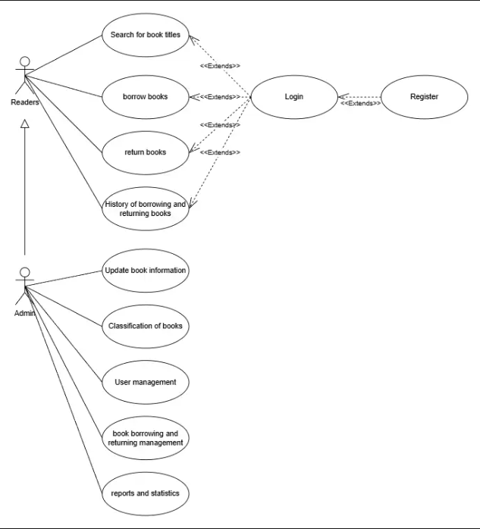

List of Actors
No. | Name of Actor | Meaning​
1 | Reader | Members /users who already have accounts and are logged into the system.
2 | Admin | System administrator .

List of Use Cases

No. | Name Use Case | Meaning | Notes (Group)
1 | Register | Register an account
2 | Login | Log in
3 | Searches for book titles | Search for book title
4 | study books | Borrow books
5 | Return books | Return the Book
6 | History of borrowing and returning books | History of borrowing and returning books
7 | Update books information | Book information update
8 | Classification of books | Book classification
9 | User skincare | User management
10 | Book Borrowing and returning management | Book borrowing and returning management
11 | Report and statistics | Reports and statistics

Use-Case Register
  - Summary
This use case allows users to register and log in (if applicable) to access the library system, search for books they wish to borrow, and register for a book loan.
  - Timeline of events
2.2.1 Main Event Flow
The use case begins when the user selects the "Register" function.
- The system requires users to provide information such as: Full name, date of birth, gender, address, phone number, email address, and password.
- The system verifies the validity of the information provided by the user and then updates the data in the system.
2.2.2 Other Event Flows
Do not have
  - This applies if the user has not entered all the required information.
If, in the main event flow, the user enters an email address (Username) that already exists in the system, the system will display an error message and prompt the user to use a different email address to register. The user can choose to return to the beginning of the main event flow or cancel the registration, at which point the use case ends.
  - Special requirements
- This function must prevent data overload by automated programs.
- Passwords must be encrypted when stored.
  - System state before executing the use case.
Do not have
  - System state after executing the use case.
If the use case is successful, the user's information will be added to the system, and the user will be able to perform searches and register to borrow books. Otherwise, the system state remains unchanged.
  - Extension points
Do not have

Login Use Case
3.1 Summary
This use case describes how a user logs into the system.
3.2 Event Flow
3.2.1 Main Event Flow
This use case begins when a user wants to log into the system.
- The system will prompt the user to enter their email and password.
- The user enters their email and password and is prompted to log in.
- The system checks the entered email and password. If correct, it allows the user to log in.
    - Other events
    - Incorrect email/password
If, during the main event flow, the user enters an incorrect email or password, the system will display an error message. The user can choose to return to the beginning of the main event flow or cancel the login, at which point the use case ends.
  - Special requirements
Do not have
  - System state before the use case begins.
The user is not logged into the system.
  - System state after the start of Use-case execution.
If the use case is successful, the user has logged into the system. Otherwise, the system state remains unchanged.
  - Extension points
Do not have

Use-case Search for books titles
4.1 Summary​
This use case allows users to search for products by entering the name of the book they are looking for.
4.2 Event Flow
4.2.1 Main Event Flow
This use case begins when the user selects the product search function.
- The system displays a form for users to enter keywords they want to search for.
- The search system will find and list products whose names contain the keyword the user just entered.
- Users select products by sorting the list of found products ( alphabetical order, category, publication date).
- The system displays a list of products according to the user's selection.
    - Other events
Do not have
  - Special requirements
Do not have
  - System state before executing the use case.
Do not have
  - System state after executing the use case.
Do not have
  - Extension points
Do not have

Use-Case Borrow Books
5.1 Summary
This use case allows users to borrow books.
  - Timeline of events
5.2.1 Main Event Flow
The use case begins when the user selects the book borrowing function.
- The system displays a list of books the user has searched for; select the book you want to borrow and press "complete".
- The system displays a book borrowing slip, and the user enters information such as: (Full name, member code, book title, book code, borrowing date, return date)
- When you receive notification that a book is available, go to the library to complete the registration process at the librarian's counter or through the automated machine, present your library card, and collect your book.
    - Other events
If the entered information is invalid or the book borrowing process fails, the system will display an error message. Users can correct the information and continue borrowing or stop the borrowing process.
  - Special requirements
Do not have
  - System state before the use case begins.
Users must be logged into the system.
  - System state after executing the Use-case
If the use case is successful, the book borrowing information will be added to the system, and a notification will be sent to the user's email address, full name, and membership code confirming the successful book borrowing. Otherwise, the system status remains unchanged.
  - Extension points
Do not have

Use-case: Return books
6.1 Summary
This use case allows users to return borrowed books.
6.2 Event Flow
6.2.1 Main Event Flow
The use case begins when the user selects the book return function.
- The system displays a list of books that the user has not yet paid for.
- Users select the books they want to return and the books that are due for return soon.
- Choose confirm or return the book to complete the book return process.
6.2.2 Other Event Flows
Do not have
6.3 Special requirements
Do not have
6.4 System state before starting use-case execution
Users must be logged into the system.
6.5 System state after use-case execution
If the use case is successful, the system will update the book's status and display a "book returned successfully" message. Otherwise, the system will not change anything.
6.6 Extension Points
If a user returns a borrowed book after the due date, the system will charge a penalty fee.

Use-case History of borrowing and returning books
  - Summary
This use case allows users to view a list of books they have borrowed and returned.
  - Timeline of events
7.2.1 Main Event Flow
The use case begins when the user views the list of books they have borrowed and returned.
- The system displays a list of borrowed and returned books in descending order.
- Users select the "View details" function for a book borrowing or return order.
- The system will display detailed information about that order, including: borrower's information, borrowing date, quantity borrowed, and whether the books have been returned or not.
7.2.2 Other Event Flows
Do not have
  - Special requirements
Do not have
  - System state before the use case begins.
Users must be logged into the system.
  - System state after executing the use case.
Do not have
  - Extension points
Do not have

Use-case Update books information
  - Summary
This use case allows the administrator, after logging in, to edit book information.
  - Timeline of events
8.3.1 Main Event Flow
This use case begins when the Admin selects the function to edit the information of a book.
- The system displays the current information about that book.
- The administrator can edit the information as desired.
- The admin pressed the update information button.
- The system will update the information you just entered.
- The system will notify you of updated results.
8.3.2 Other Event Flows
- If the administrator cancels the action, the system will not update the information and the event flow will restart.
- If, in the main event flow, the Admin fails to enter required information (Book title, author, publication date), the system will display an error message. The Admin can choose to return to the main event flow or cancel the update, at which point the use case will end.
  - Special requirements
Do not have
  - System state before the use case begins.
The administrator must be logged into the system.
  - System state after executing the use case.
If the use case is successful, the information will be updated. Otherwise, the system state will not change.
  - Extension points
Do not have

Use-case Classification of books
  - Summary
This use case allows the administrator to categorize books.
  - Timeline of events
9.3.1 Main Event Flow
This use case begins when the Admin selects the book classification function.
- The system includes a section for creating book categories.
- The administrator then proceeded to name the book categories and select the books for each category.
- The admin pressed the update button.
- The system will automatically update the list that the Admin has categorized.
- The system will notify you of updated results.
9.3.2 Other Event Flows
- If the administrator cancels the action, the system will not update the information and the event flow will start again.
- If the Admin hasn't named the book category in the main event flow, the selected books won't be saved as a category. The system will display an error message, prompting the Admin to name the book category for classification or to cancel the classification; at this point, the use case will end.
  - Special requirements
Do not have
  - System state before the use case begins.
The administrator must be logged into the system.
  - System state after the use case has been executed.
If the use case is successful, the system will be updated; otherwise, the system will remain unchanged.
  - Extension points
Do not have

Use-case: User management
  - Summary
This use case allows the administrator to manage system user information. This includes functions for viewing, adding, editing, and deleting users.
  - Timeline of events
10.3.1​ Main events
This use case begins with the Admin managing users.
- The system displays a list of users.
- If the Admin selects "Add", the event flow for adding a user account is executed.
- If the Admin selects "Update" a user, the user account update event is executed.
- If the Admin selects the "Delete" function for a user, the user account deletion event is executed.
      - Add user account
- The Admin system enters user information.
- The admin enters the information and requests additional details.
- The system checks the validity of the information and adds it to the system.
- The system will notify you of additional results.
      - Update user account
- The system displaying user information needs updating.
- The administrator will edit the information as desired.
- Admin requests an update to the information.
- The system checks the validity of the information and updates it accordingly.
- The system will notify you of updated results.
      - Delete user account
- The system requires the administrator to confirm the user deletion operation.
- If the administrator confirms the deletion, the system removes the user and all information related to that user from the system.
- The system notifies you of the deletion results.
10.3.2 Other Event Flows
Do not have
  - Special requirements
The user list should be paginated to improve system performance.
  - System state before the use case begins.
The administrator must be logged into the system.
  - System state after executing the use case.
If the use case is successful, user information will be added, updated, or deleted from the system. Otherwise, the system state remains unchanged.
  - Extension points
Do not have

Use-case Books borrowing and returning management
  - Summary
This use case allows the administrator to manage (view, add, edit, delete) book borrowing and returning requests.
  - Timeline of events
11.3.1 Main Event Flow
This use case begins when the Admin selects the function to manage book borrowing and return requests.
- The system displays the list of loan applications in descending order (newer applications appear first).
- If the Admin selects the "Update" function, the event flow for updating the loan/return order is executed.
- If the administrator selects the "Delete" function, the current entry for the loan/return request will be deleted.
      - Update book borrowing/returning records.
- The system displays information about book borrowing/returning requests that needs updating. This includes information such as book title, borrower/returner information, and book status.
- The administrator will edit the information as desired.
- Admin requests an update to the information.
- The system checks the validity of the information and updates it accordingly.
- The system will notify you of updated results.
11. 3.1.2 Deleting book borrowing/returning records
1. The system requires the Admin to confirm the action of deleting a book borrowing/returning request.
2. If the Admin confirms the deletion, the system will remove the order and all information related to this book borrowing/returning order from the system.
3. The system notifies you of the deletion results.
11.3.2 Other Event Flows
Do not have
  - Special requirements
Do not have
  - System state before the use case begins.
The administrator is currently logged into the system.
  - System state after executing the use case.
If the use case is successful, the book borrowing/returning request will be updated or deleted from the system. Otherwise, the system state remains unchanged.
  - Extension points
Do not have

Use-case Report and statistics
  - Summary
This use case allows the administrator to generate system reports and statistics.
  - Timeline of events
12.2.1 Main Event Flow
This use case begins when the Admin selects the reporting and statistics function.
- The system will then allow the administrator to select the time period they want to include in the statistics.
- The system will automatically compile and statistically analyze data on book borrowing/returning requests during that period.
- Admins can click to view details such as: Total number of book borrowing/returning requests, number of returned requests, number of outstanding requests, number of new members, and total number of members.
12.2.2 Other Event Flows
Do not have
  - Special requirements
Do not have
  - System state before the use case begins.
The administrator must be logged into the system.
  - System state after executing the use case.
If the use case is successful, the system will display reports and statistics within the selected time period. Otherwise, if the administrator has not entered a time period, the system will display an error message and prompt the administrator to enter the information or cancel the operation.
  - Extension points
Do not have

Data Flow Diagram(DFD)
- DFD Level 0
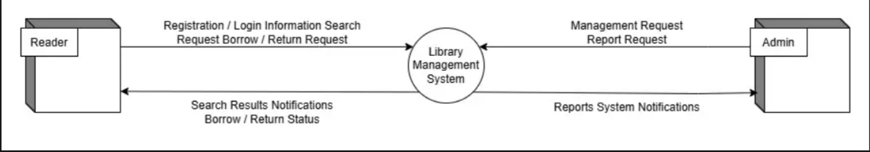
DFD Level 0 describes the library management system as a single process, illustrating the data flows exchanged between the system and external entities, namely the Reader and the Admin.
- DFD Level 1
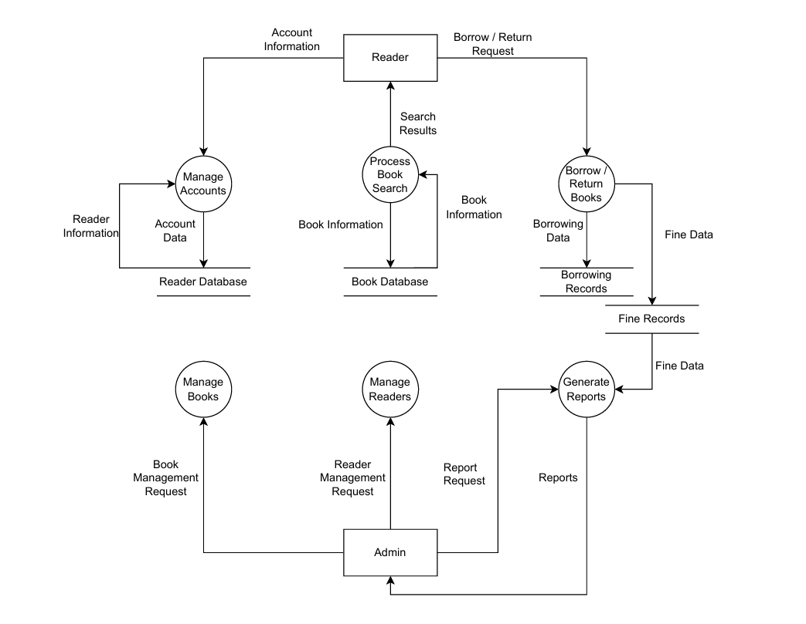
DFD Level 1 is constructed to decompose the Library Management System process from DFD Level 0 into its major sub-processes, reflecting the data flows between entities and the system's data stores.

Class Diagram
- Overview Diagram
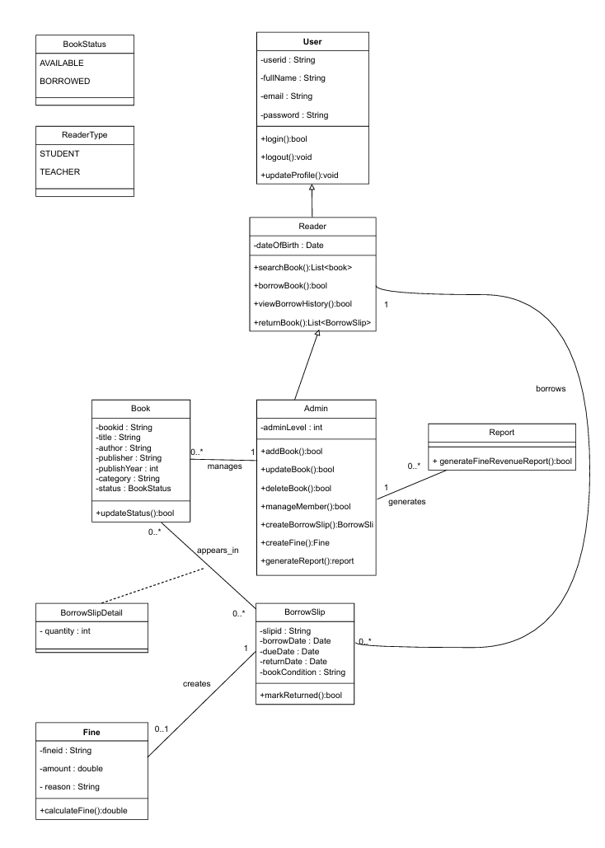

Data Model

Overview Diagram
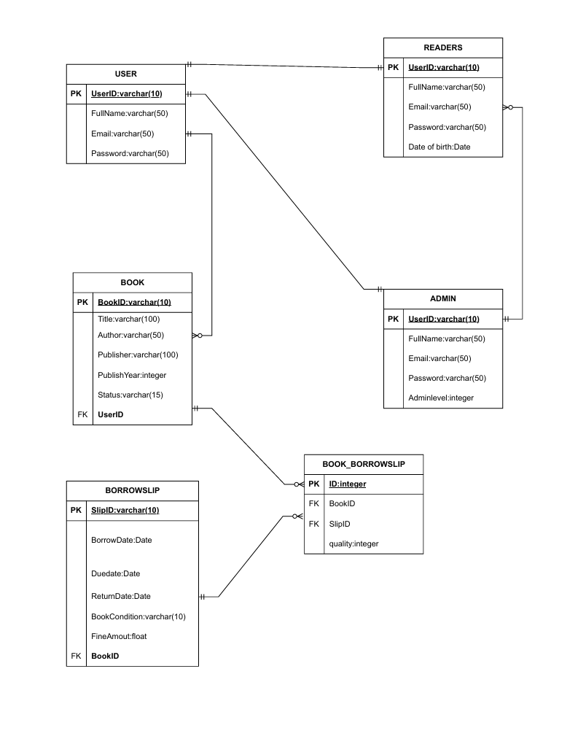

Interface Design Description
- General Interface Design Description
Language: 100% Vietnamese.
Style: Simple – Clear – User-friendly.
Responsive: Automatically adjusts to screen sizes (Desktop / Tablet / Mobile).
Role-based UI/Access Control: Readers and Admins are presented with different interfaces and functionalities.
Color Palette: Light background with Blue/Green accent colors.
Typography: Clear and legible fonts.
- Overall Navigation Structure
  - Navigation Bar
Library Logo
Home
Book Search
Borrow Books
Return Books
Borrowing & Return History
Personal Profile
Logout
- Reader Interface Description
  - Account Registration Interface
Purpose: To allow users to create a new account.
UI Components:
Title: "Reader Account Registration"
Input Fields:
Full Name
Date of Birth
Phone Number
Email (Username)
Password
Confirm Password
Buttons:
Register
Cancel
System Feedback:
Error messages for missing data or duplicate emails.
Successful registration notification.
  - Login Interface
Purpose: To authenticate users.
UI Components:
Email
Password
"Login" Button
"Register an Account" Button
Notifications:
Invalid email/password.
Successful login.
  - Reader Homepage Interface
Components:
Quick Search Bar
Featured / New Arrivals List
Upcoming Return Deadlines Notifications
  - Book Search Interface
Components:
Keyword Search Box
Filters:
Book Title
Author
Publication Year
Search Results (Table View):
Book ID
Title
Author
Year of Publication
Status (Available/Unavailable)
"Borrow" Button
  - Book Borrowing Interface
Components:
Selected Book Information
Borrowing Form:
Borrower's Full Name
Member ID
Borrow Date
Due Date
Buttons:
Confirm Borrow
Cancel
  - Book Return Interface
Components:
List of Currently Borrowed Books
Status: On Time / Overdue
"Return Book" Button
Notifications:
Successful return message.
Display of fine/penalty fees if overdue.
  - Borrowing & Return History Interface
Components:
History List (Sorted by time/chronologically)
"View Details" Button
Detailed View:
Book Title
Borrow Date – Return Date
Status
  - Personal Profile Interface
Components:
Personal Information Display
"Update Profile" Button
Change Password
- Admin Interface Description
  - Admin Dashboard
Components:
Total Books
Currently Borrowed Books
Overdue Books
Total Readers
Total Fines Collected
  - Book Management Interface
Components:
Book List
Buttons:
Add Book
Update
Delete
Add/Edit Book Form:
Book ID
Title
Author
Publisher
Publication Year
4.3 User Management Interface
Components:
User List
Buttons:
Add
Edit
Delete
4.4 Borrowing & Return Management Interface
Components:
Borrowing Records List
Status: Returned / Not Returned / Overdue
Update / Delete Borrowing Records
4.5 Reports & Statistics Interface
Components:
Statistics:
Total Borrowing Transactions
Number of Overdue Books
Fine Revenue
"Export Report" Button

